Supplementary Material
Rheological Behavior of Living Cells is Timescale Dependent
Dimitrije Stamenović^{1,}*, Noah Rosenblatt¹, Martín Montoya-Zavala², Benjamin D. Matthews², Shaohua Hu³, Béla Suki¹, Ning Wang⁴, and Donald E. Ingber²
¹Department of Biomedical Engineering, Boston University, Boston MA 02215, USA
²Departments of Pathology and Surgery, Children’s Hospital and Harvard Medical School, Boston, MA 02115, USA
³Deaprtment of Environmental Health, Harvard School of Public Health, Boston, MA 02115, USA
⁴Department of Mechanical Science and Engineering, University of Illinois at Urbana-Champaign, Urbana, IL 61801, USA

*To whom all correspondence should be addressed: dimitrij@bu.edu

Supplementary Materials and Methods

Oscillatory Measurements
Ferromagnetic beads (4.5-μm diameter) coated with the integrin-binding RGD (Arg-Gly-Asp) peptide were added to cultured human airway smooth muscle (HASM) cells plated for 4-6 h on collagen-1-coated (0.2 mg/ml), membrane-bottom wells (18,000 cells/well) for 20 min, and then unbound beads were washed away with serum-free medium (1). Beads were magnetized in a horizontal direction, and then twisted by a sinusoidally varying vertical magnetic field, and the horizontal bead displacements were traced (2). For each bead, we computed the magnitude of the dynamic modulus (|G*|) as the ratio of the amplitude of the applied specific torque to the amplitude of the corresponding bead horizontal displacement. This ratio was multiplied by a geometrical factor to obtain |G*| in units of mechanical stress (3). Two different force regimens were used: Protocol 1, 0.1-1,000 Hz (0.1-100 Hz, 5 cycles; 100-1,000, 10 cycles; applied specific torque of ~90 Pa) and Protocol 2, 0.001-1 Hz, (0.001 Hz, 1 cycle; 0.005 Hz, 2 cycles; 0.008 Hz, 3 cycles; 0.01 Hz, 4 cycles; 0.05-1 Hz, 5 cycles; specific torque amplitude of ~38 Pa). These protocols were used to shorten the duration of measurements and to reduce the effect of cytoskeletal remodeling. Measurements were made during ascending and descending frequency sweeps (data were similar in both cases) in Protocol 1, and only during the ascending frequency sweep in Protocol 2. Since at a given applied torque bead displacement amplitude increased with decreasing frequency (Fig. S1), and thus might become excessive at low frequencies, we used the lower torque amplitude in Protocol 2 to prevent excessive bead motion and stay within linear range. To test whether different specific torque amplitudes at low and high frequencies might be a cause of two different power-law regimes, we carried out low and high frequency measurements with single specific torque amplitude of ~38 Pa. We again observed two power-law regimes. Protocol 2 also was repeated in cells treated with jasplakinolide (0.1 µM for 3 min). The comparison between the low-frequency oscillatory responses of control and jasplakinolide-treated cells is shown in Fig. S2.
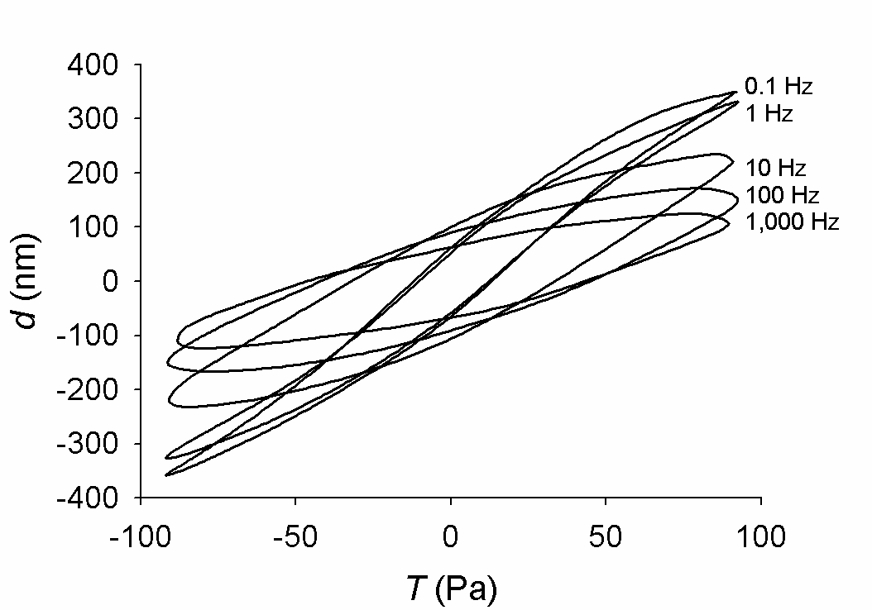

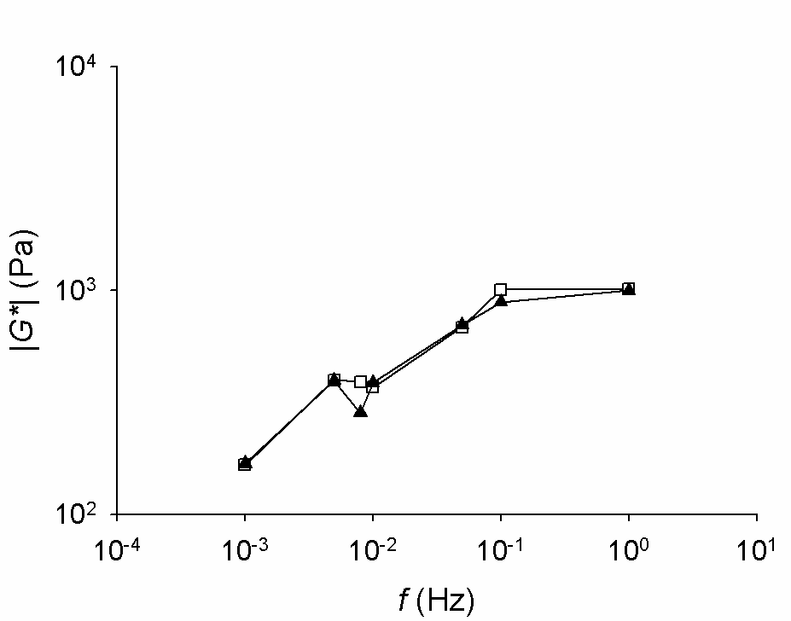
FIGURE S1 Bead horizontal displacements (d) vs. specific torque (T) loops for different frequencies obtained from HASM cells using oscillatory magnetic cytometry. With increasing frequency, displacement amplitude decreases. Above 10 Hz, the loops appear elliptic (i.e., linear), but below 10 Hz they appear sigmoid (i.e., non-linear), indicating stiffening behavior. Loops are baseline means from ~100 beads from a single well.

FIGURE S2 The magnitude of the dynamic modulus (|G*|) vs. frequency (f) relationship of HASM cells prior to (solid triangles) and after addition of jasplakinolide (open squares) measured by oscillatory magnetic cytometry at the low-frequency range (10⁻³-10⁰ Hz). Data are median values from ~100 beads.
Harmonic Distortion Analysis
We did a harmonic distortion analysis of individual bead oscillatory motions using an established method (4). The analysis was carried out for each individual bead and for each measured frequency. From this analysis we calculated the harmonic distortion index (K_{d}), defined as the square root of the ratio of the output power due to system nonlinearities to the total input power. Values of K_{d} were corrected for non-zero energy at non-input frequencies due to noise, by performing the harmonic distortion analysis of the input signal from which we obtained the contribution of noise to the harmonic distortion (Fig. S3).
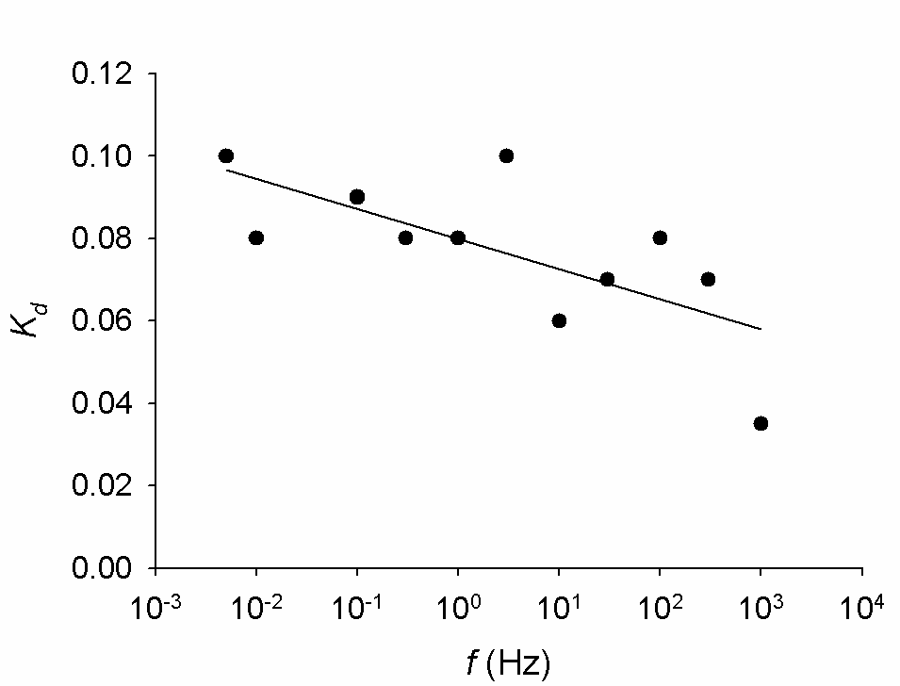

FIGURE S3 The harmonic distortion index (K_{d}) vs. frequency (f) relationship for HASM cells. K_{d} increases with decreasing f, indicating the increasing presence of nonlinearities at low frequencies. Data are median values from 20-90 beads; solid line is a linear regression in the semi-log domain (slope = –0.0074; r² = 0.48, p = 0.0179).

Creep Measurements
The RGD-coated super-paramagnetic beads were added to cultured bovine capillary endothelial (BCE) cells plated for 18-24 h on 35-mm fibronectin-coated (500 ng/cm²), glass-bottomed dishes (5×10⁴ cells/dish) for 20 min, and unbound beads were washed away with serum-free medium (5). The electromagnetic pulling cytometry device applies a constant pulling force to integrin-bound magnetic beads on the cell’s apical surface, approximately 45° relative to the substrate (5). We considered only those beads that were located on the apical surface above the central region of the cell. The horizontal component of the creep displacement of individual beads was measured optically (one bead per cell) (5). We measured the creep response from 0.02-120 s (sampling rates 50 Hz from 0.02-5.5 s and 6 Hz from 5.5-120 s) with pulling force of ~350 pN. The reason for the variable sampling rate was to obtain more evenly spread data points in the log-log domain.
Creep data exhibited two power-law regimes, one less time-dependent at short times, with power law exponent α₁, and the other more time-dependent at long times, with power-law exponent α₂ (Fig. S4), separated by a plateau regime. The data were consistent with previously reported creep data from BCE cells obtained with the same technique (5), as well as with published data for myocytes obtained with a different method (6). Importantly, the multi-power-law behaviors observed during creep and oscillatory measurements indicate a time-frequency consistency that characterizes viscoelastic systems, apparently including living cells.
We fitted creep data in the log-log domain with the following multi power-law function
$u=\left\{\begin{matrix}C_{1}t^{α_{1}}\begin{matrix}, & \text{for}\begin{matrix}t<t_{1}\end{matrix}\end{matrix} \\ C_{1}t_{1}^{α_{1}}\begin{matrix}, & \text{for}\begin{matrix}t_{1}t≤t_{2}\end{matrix}\end{matrix} \\ C_{2}t^{α_{2}}\begin{matrix}, & \text{for}\begin{matrix}t>t_{2}\end{matrix}\end{matrix}\end{matrix}\right.$, (S1)
where u is bead displacement, t is time, C₁, C₂, α₁, α₂, t₁ and t₂ are constants with constrains $C_{1}t_{1}^{α_{1}}=C_{2}t_{2}^{α_{2}}$and t₁ ≤ t₂.
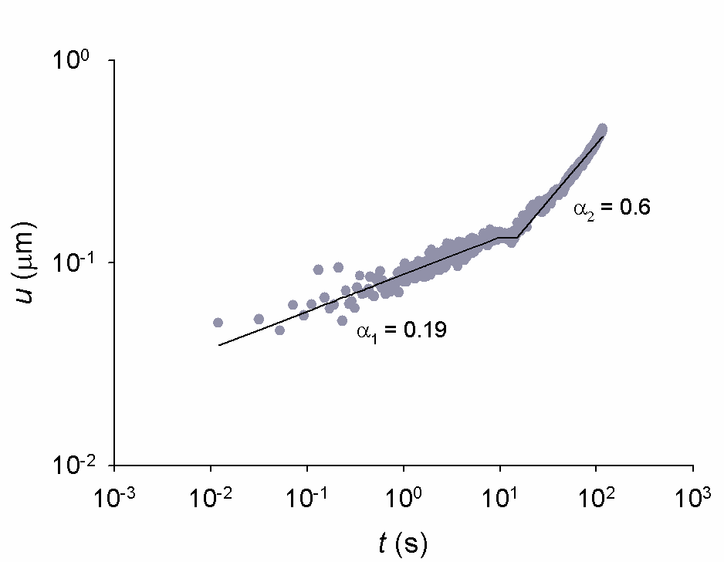

FIGURE S1 The creep displacement (u) vs. time (t) relationship measured in BCE cells using electromagnetic pulling cytometry. The creep response follows a short-time (0.02-9 s) power-law regime, with α₁ = 0.19, and a long-time (14-120 s) power-law regime, with α₂ = 0.6, separated by a plateau region (9-14 s). The values of α₁ and α₂ are significantly different (p < 0.001). The solid line is the least squares best fit of the data (gray circles) by Eq. S1; data are means from n = 4 beads.

References
- Rosenblatt, N., S. Hu, J. Chen, N. Wang, and D. Stamenović, D. 2004. Distending stress of the cytoskeleton is a key determinant of cell rheological behavior. Biochem. Biophys. Res. Commun. 321: 617-622.
- Fabry, B., G. N. Maksym, J. P. Butler, M. Glogauer, D. Navajas, and J. J. Fredberg. 2001. Scaling the microrheology of living cells. Phys. Rev. Lett. 87: 148102.
- Mijailovich, S. M., M. Kojic, M. Zivkovic, B. Fabry, and J. J. Fredberg. 2002. A finite element model f cell deformation during magnetic bead twisting. J. Appl. Physiol. 93: 1429-1436.
- Suki, B., Z. Hantos, B. Daroczy, G. Alkaysy, and S. Nagy. 1991. Nonlinearity and harmonic distortion of dog lungs measured by low-frequency forced oscillations. J. Appl. Physiol. 71: 69-75.
- Overby, D. R., B. D. Matthews, E. Alsberg, and D. E. Ingber. 2005. Novel dynamic rheological behavior of individual focal adhesions measured within single cells using electromagnetic pulling cytometry. Acta Biomater. 1: 295-303.
- Desprat, N., A. Richert, J. Simeon, and A. Asnacios. 2005. Creep function of a single living cell. Biophys. J. 88: 2224-2233.

