Wu Xue-Hong
General Information:
Name | Wu Xue-Hong | 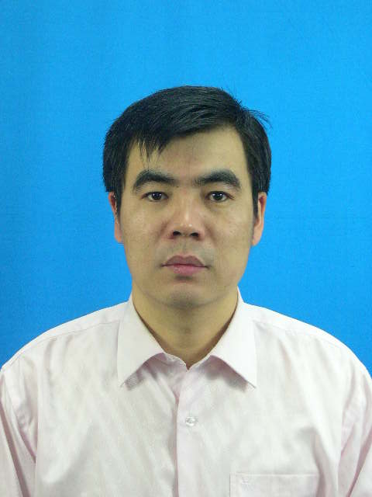
Sex | Male
Date of Birth | 08-09-1979
Degree | Ph.D
Mail Add. | P.O.Box 2334, Xi’an Jiaotong University, Xi’an Shaanxi 710049, China
TEL. | +86-29-82663232-802
E-Mail | wuxh1212@yahoo.com.cn
Education:
- 2005.9-2009.03, Engineering Thermophysics, Xi’an Jiaotong University, Ph.D. Super- advisor: Prof. Tao Wen-Quan. Thesis Title: The Meshless Local Petrov-Galerkin (MLPG) Method and Its Application in Heat Transfer and Fluid Flow Problems.
- 2002.09-2005.06, Thermal Engineering, Guangdong Ocean University, M.E. Superadvisor: Prof. Ling Chang-Ming. Thesis Title: An Experimental and Numerical Investigation of Heat Transfer and Friction Characteristics of The Slit of Wavy Fin- and Tube Heat Exchangers
- 1997.09-2000.06, Chemical Engineering, Nanyang Institute of Technology, Henan.
Working Experiences:
- 2009.04-now, School of Electromechanical Science and Engineering, Zhengzhou University of Light Industry, Lecturer.
Research Interests:
- Meshless method
- Enhanced heat transfer
- Computational fluid dynamics and heat transfer
- Proper orthogonal decomposition
Honors:
- Dow Chemical Scholarship 2008 – 2009
- Excellent Graduate Students 2008 – 2009
- Excellent Graduation
Publications:
Journal Paper
- Wu Xuehong, Shen Shengping,Tao Wenquan, meshless local petrov-galerkin collocation method for two-dimensional heat conduction problems. CMES: Computer Modeling in Engineering & Sciences. Vol.22,no.1, pp.65-76,2007
- Wu Xuehong,Tao Wenquan, meshless method based on the local weak-forms for steady state heat conduction problems, International Journal of Heat and Mass Transfer 51 (2008) 3103–3112
- Ding Peng ,Wu Xuehong, He YaLing, Tao Wenquan, A fast and efficient method for predicting fluid flow and heat transfer problems, ASME: Journal of Heat Transfer, MARCH 2008,130:032502-1-17
- Wu Xuehong, Li Zengyao, Ma Liangdonng, Shengping,Tao Wenquan, A hihgly accurate meshless method for convection-diffusion problems, Journal of Engineering Thermophysics (China), 2008，29（9）:1561-1563
- Li Jun, Wu Xuehong, Xu Qing, Ling Changming, Zhang Zhengguo, Numerical simulation of heat transfer and flow performance of slit surfaces of wave plate for fin and tube heat exchangers, Journal of Guangdong Ocean University,28(4):82-85,2008
- Wu Xuehong, Li Zengyao, Shen Shengping,Tao Wenquan，Numerical simulation of heat condution problems on irregular domain by using MLPG Method，Journal of Engineering Thermophysics (China),(accepted)
International Conferences
- Wu Xuehong, Shen Shengping, Li Zengyao, Tao Wenquan, Meshless local petrov-galerkin method for convection- dominated flow problems, 2007 Asian Symposium on Computational Heat Transfer and Fluid flow, Xi’an, CHINA, Oct 17-21.Xi’an Jiaotong University Press, Editors by Wen-Quan Tao and Ya-Ling He
- Wu Xuehong, Shen Shengping,Tao Wenquan, A stabilized MLPG method for incompressible fluid flow simulation, the ICCES Meshless Conference, ICCESS08, SuZhou,CHINA.

