Trusses
Mostly empty space, but very efficient.

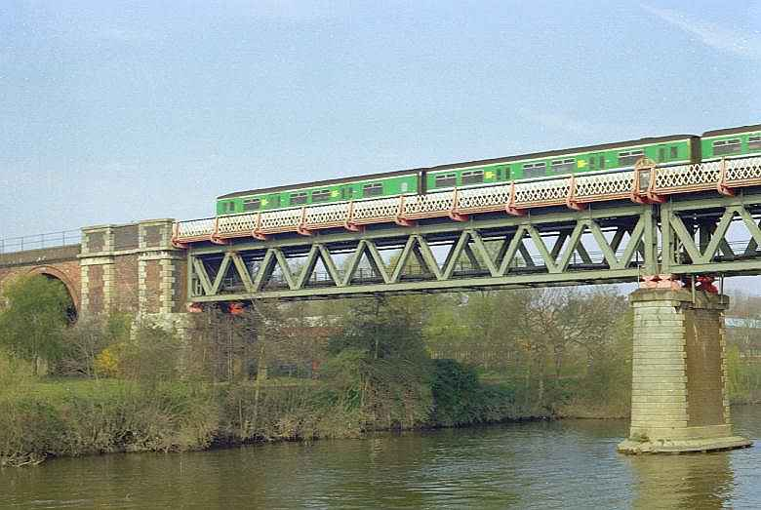
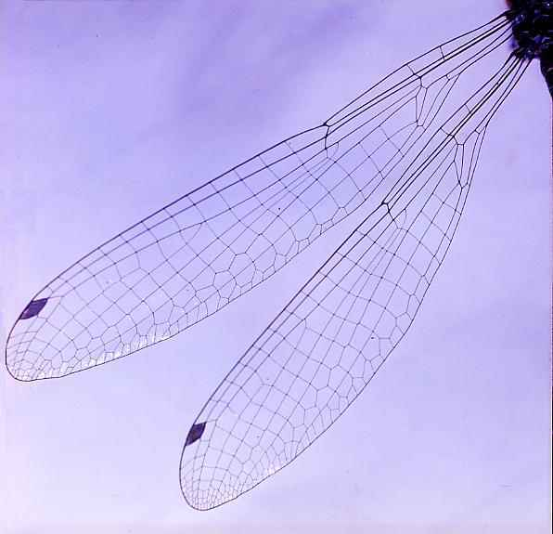
http://www.brantacan.co.uk
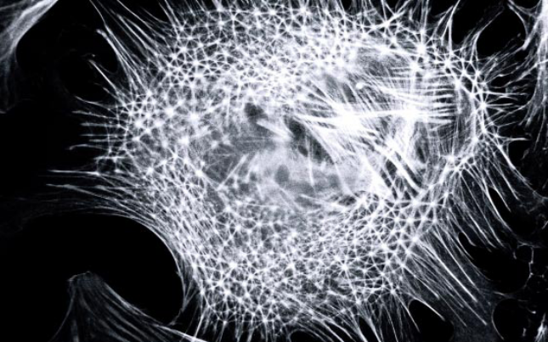
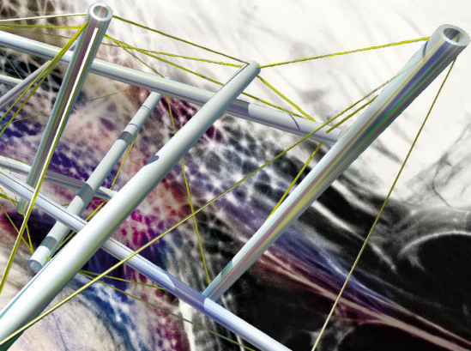
Tensegrity. Ingber, Scientific American, January 1998

What is a truss?
- A structure consisting of rods and wires.
- Forces are applied on the nodes (or joints).
- Each element (or member) is under an axial load. No bending or torsion.
- A tie is under tension.
- A strut is under compression.
- Wikipedia entry on trusses: http://en.wikipedia.org/wiki/Truss

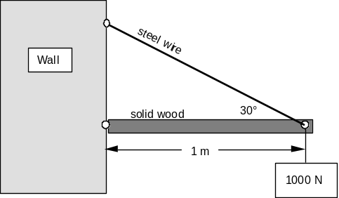
A 2-member truss
- A steel tie and a wood strut.
- The structure is intended to sustain a weight.
- What design principles can we learn from this simple structure?

Failure modes
- Will the steel wire be pulled out from the wall, or the wood crush into the wall? Will the steel wire break from the wood? These joints contribute little to the total weight of the structure. We’ll just over design the joints so that they do not fail before the tie and the strut.
- The steel tie is in tension, and may fail by yield or fracture.
- The wood strut is in compression and may fail by yield or buckle.

Design for safety
- Calculate internal force in each element.
- In the tensile element, limit the force by strength.
- In the compressive element, limit the force by strength and by Euler’s formula.

A 3-element truss. Now consider a 3-element truss. We try to determine the internal forces in the three elements.

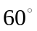
L
100N
2L
2L
100N
f₁
f₂
f₂

Force balance of the node. Draw the free-body diagram to expose the internal force in every element. The force balance of the node gives
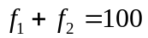.
This equation is insufficient to determine the two forces. When force balance alone cannot determine all the internal forces, the structure is known as a statically indeterminate structure. By contrast, the 2-element truss analyzed above is a statically determinate structure.
Express internal force in each element in terms of the nodal displacement. To determine internal forces in a statically indeterminate structure, we need to invoke displacement. Let u be the displacement of the node. For element 1, the length is L and the elongation is u, so that the strain is
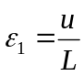.
For element 2, the length is 2L and the elongation is 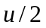, so that the strain is
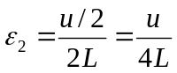.
Recall that Hooke’s law relates stress to strain, 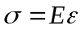, where E is Young’s modulus, is stress, and is strain. Let the cross section of every element be A. The force in element 1 is
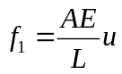.
The force is linear in the displacement. The force in element 2 is
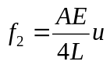.
Force balance at the node provides an equation for the nodal displacement. Inserting these force-displacement relations into the force balance equation, we obtain that
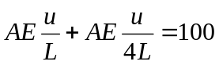.
This is a linear algebraic equation for the displacement of the node. Solving for the displacement, we obtain that
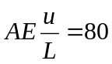.
Consequently, the forces in the two elements are 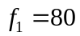 and 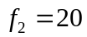.

How Does the Computer Code Work?
- The unknowns are nodal displacements.
- For each element, express internal forces in terms of the nodal displacements.
- Nodal force balance gives a set of linear algebraic equations for the displacements. Each node has three displacement components. If the truss has N nodes, the total number of the nodal displacements is 3N. Each node contributes 3 force balance equations. The N nodes result in 3N equations for the 3N unknown displacements.
- Solve this set of linear algebraic equations.
For the computer to do all this, it has to be systematic. The following outlines an algorithm that the computer follows.
Elongation-displacement relation. In the three-dimensional space, locate an element by the coordinates of its two nodes, 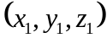 and 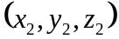. The length of the element is
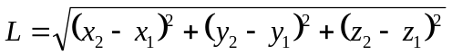.
The direction cosines of the element (i.e., the components of the unit vector n along the axis of the element, pointing from node 1 to node 2) are
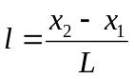, 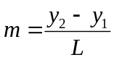, 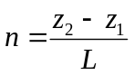.
Denote the displacement vector of node 1 by 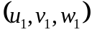, and that of node 2 by 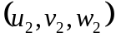. The elongation of the element, , is the difference of the two displacement vectors, projected along the axis of the element, 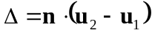, or
.
Relate internal force of each element to the nodal forces. Let A be the cross-sectional area of the element, and E be Young’s modulus of the material. Under an axial force P, the length of the element changes by . In the element, the stress is 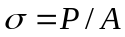, and the strain is 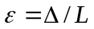. Hooke’s law relates the stress and the strain: . Consequently, the force and the elongation are linearly proportional:
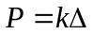,
where the stiffness of the element is 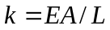.
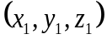
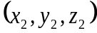
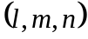
P
P
P
P
f₂
g₂
h₂
f₁
g₁
h₁

By Newton’s third law, the element applies a force on node 1, of magnitude P and in the direction of the element axis, 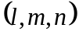. Projected onto the coordinate axes, this force has the components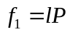, 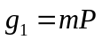 and 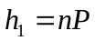. Each force component is linear in the displacement components of the two nodes:
,
,
.
The force P acts on node 2 in the direction -, and has three components 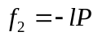, 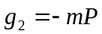 and 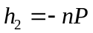. Each force component is linear in the displacement components of the two nodes:
,
,
.
List the nodal displacements of the element as a column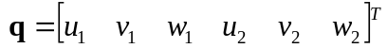. Similarly, list the forces acting on the two nodes by the element as a column 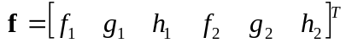. In a matrix form, we write the force-displacement relation as
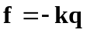.
The internal forces on the nodes are linear in the displacements. The element stiffness matrix is
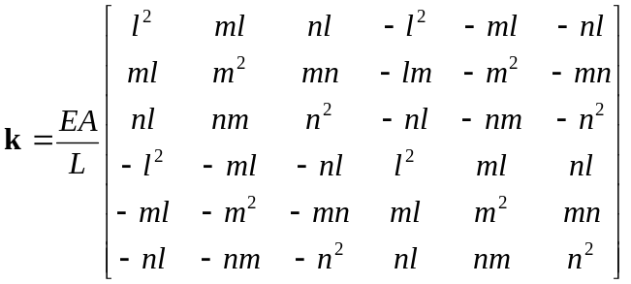.
Force balance of every node. The truss has N nodes, labeled as 1, 2, 3,…, N. Each node has three displacement components. List the displacements of all the nodes as a column Q; for example, the three displacement components of node i enter at the locations 3i-2, 3i-1, 3i. Say a particular element has node i and node j. The element stiffness is a 6 by 6 matrix. In terms of the global displacement column, the matrix relation between the nodal displacements and the forces exerted on the two nodes by the element look like this:

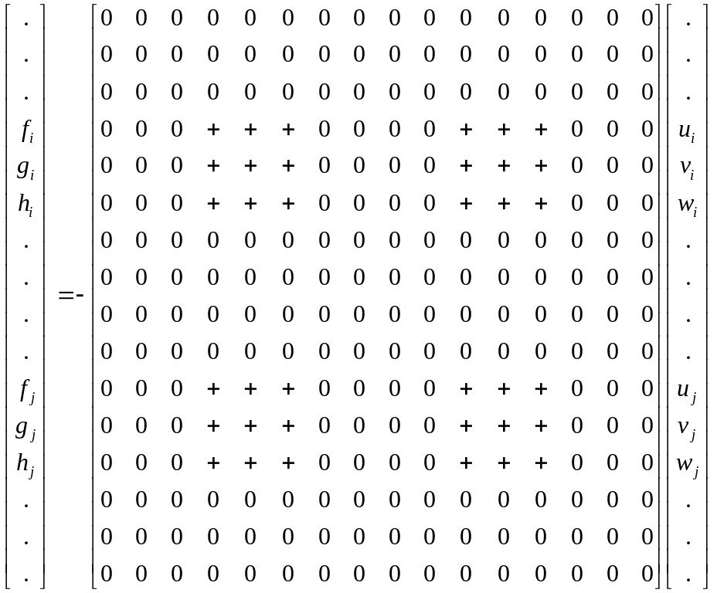
3i-2 3i-1 3i 3j-2 3j-1 3j
3j-2
3j-1
3j
3i-2
3i-1
3i

Summing the forces over all elements in the truss, we obtain the internal forces on all the nodes as a column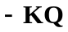, where K is the global stiffness matrix of the truss. The 36 entries of the stiffness matrix of the particular element should be added to the global stiffness matrix as shown in the figure. The computer code does this assembly of the global stiffness matrix. In homework you will work through an example to see how it is done.
List the external forces on all nodes as a column F. The balance of the internal and external forces on every node gives
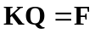.
This is a matrix equation between the nodal displacements and the external forces. The external forces are known column, and the nodal displacement column are to be determined.
Treating a support. If a node is supported by a wall, either one, or two, or three of its displacement components vanishes. Let us consider one such displacement component. Its location in the Q column is 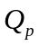. Because we already know its value, = 0, we eliminate it from the Q column. Correspondingly, we eliminate pth row and pth column from the global stiffness matrix K, as well as the pth entry in the F column. We do this for all displacement components so constrained. As a result, the linear algebraic equation has fewer unknowns. The computer solves this linear equation by using Gaussian elimination.
Reaction forces. After we have solved all the unknown displacements, we can go back to the original equation, the pth entry in the column KQ gives the force of the wall on the node (i.e., the reaction force).
Stress in each element. Calculate the stress in each element in terms of the nodal displacements:
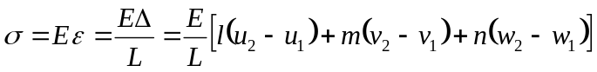.
The algorithm. If you find the theory dizzy, relax. The engineer who uses ABAQUS to analyze a truss may care even less about the theory. Computer will do the work.

Here is what the engineer needs to do to analyze a truss:
- Specify the geometry of the truss.
- Assign a number to each node, and a number to each element
- For each element, input cross-sectional area and Young’s modulus.
- Input external forces on the nodes.
- Input the nodes and the directions for which the displacements vanish.

Here is what the computer will do:
- For each element, form the element stiffness matrix.
- Assemble the global stiffness matrix.
- Handle the displacement constraints.
- Solve the linear algebraic equation.

Here is the output of the computer:
- Displacements of all nodes.
- Stresses in all elements.
- Reaction forces at all supports.

